Sales Tracker - Calendly Sync — how it works
Trigger: Calendly Trigger node, subscribed to two events: invitee.created (new booking) and invitee.canceled (cancellation or reschedule — Calendly doesn't have a distinct "rescheduled" event, so it's inferred later).
1. Branch on event type
Is Created (IF node) checks {{ $json.event }} === "invitee.created" and splits into two paths.
2A. New booking path
- Build Created Fields (Code) — extracts bookingId (parsed from the event URI), name, email, event type, start/end times, computes the Monday of that week and the YYYY-MM month, and detects if this booking is itself a reschedule of an older one (via Calendly's old_invitee field).
- Get Existing Rows (Created) — GETs the full Bookings sheet via raw HTTP (not the native Sheets node — that one had a proven schema-drift bug that corrupted data when built programmatically).
- Merge Row (Created) (Code) — finds if this bookingId already has a row; if yes, overwrites it in place (handles duplicate webhook deliveries); if no, appends at the next free row. Preserves any existing "Attended"/"Match Status"/"Outcome" values so a later re-sync doesn't clobber classification data written by the other workflow.
- Write Row (Created) — PUTs the single merged row back via the Sheets API.
2B. Cancel/reschedule path
- Build Canceled Fields (Code) — same bookingId parsing, but status becomes "Rescheduled" if Calendly's payload includes a new_invitee link, otherwise "Canceled".
- Get Existing Rows (Canceled) → Merge Row (Canceled) → Write Row (Canceled) — same merge-by-bookingId pattern, just updating the status column while preserving everything else already on that row.
3. Dashboard regeneration (runs after either branch)
Both write paths converge into:
- Fetch All Bookings — re-reads the entire Bookings sheet now that it's updated.
- Build Bookings Array (Code) — reshapes the raw rows into the JSON array your dashboard's JavaScript expects (bookingId, name, email, eventType, startDate, endDate, status, attended, outcome).
- Read Template File — reads the static HTML template from C:/Users/klarkyy/.n8n-files/bookings_dashboard_template.html.
- Extract Template Text — pulls it out of n8n's binary format into plain text.
- Build Final HTML (Code) — does a string replace, swapping the template's /*__BOOKINGS_DATA__*/[] placeholder for the real JSON array.
- Convert to File → Write Dashboard File — writes the finished HTML to C:/Users/klarkyy/Downloads/sale tracker.html, overwriting it every run.
Error handling
Every I/O node (Sheets reads/writes, file read/write) has its error output wired to Notify Error, which emails you a summary of what failed and which Calendly event triggered it. A failure in one branch doesn't crash the run — it just alerts you.
Net effect
Every real booking, cancellation, or reschedule in Calendly → one merged row in Bookings (no duplicates) → a freshly regenerated sale tracker.html you can open any time to see current data. Nothing here talks to the Dashboard or Summary tabs — those are separate, formula-driven and untouched by this workflow.

Cancel/Reschedule
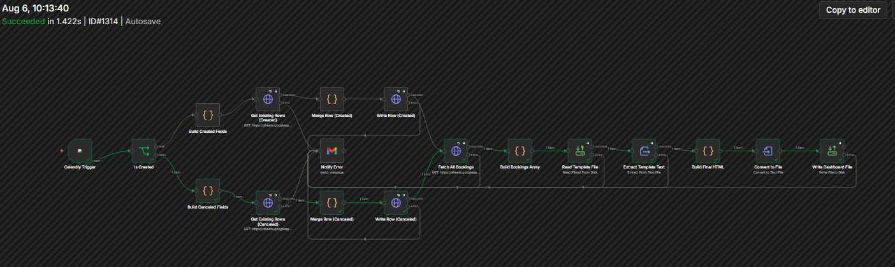

Book
